GI Bill Data Service Errors

This document will describe the errors and warnings provided by the GI Bill Data Service (GIDS). The new GIDS features more robust error handling and notifications when issues caused by uploading data files (*.csv) occur. It should be stated at the outset that the new GIDS is reporting on errors that the previous version did not. This does not imply that these errors didn’t occur in the previous version of GIDS, but rather that all errors and warnings are now being reported.

As a matter of best practice, notify the Digital service team if you are aware of any impending changes to any of the CSVs used by GIDS. Please create a Github (<https://github.com/department-of-veterans-affairs/vets-website/issues>) issue notifying the Digital service team that CSV changes are expected, as soon as possible. If legally permissible, please attach the CSV to the issue when it becomes available.

# Uploading CSV Errors

The major functional difference when uploading new files between the old and new systems is that the new GIDS will successfully complete the upload even if there are data issues with certain rows. Many CSVs uploaded by GIDS have rows with bad data, however, this does not mean the CSV is faulty, but rather that the data is incomplete for some institutions. This has been a common occurrence with these data files, and does not necessarily mean the entire CSV is suspect.

There are several different types of errors or warnings:

1. There was an issue with the upload in general (file not transmitted properly, database issues, and so on.
2. A validation error that alerts you to an issue with a row of data that should be reviewed. In this case, the upload is successful.
3. Issues with missing columns. If the missing columns do not contain required information, then this is a warning that the format of the CSV has changed.
4. Issues with extra (unexpected) columns. This is a warning that the format of the CSV has changed.
5. Issues with renamed columns. In these cases warnings for missing columns (the old names) and extra columns (the new names) will be provided. This is a warning that the format of the CSV has changed.

### General Upload Errors

The first type of issue is always fatal, and will stop the upload. These should be reported to the Digital Service team as soon as possible, preferably as an issue in Github (<https://github.com/department-of-veterans-affairs/vets-website/issues>). When communicating this issue, please be as informative as possible – what you were trying to do, what error you received (preferably a screenshot), frequency of occurrence if not the first time, and to the extent legally permissible any data files you were using.

### Validation Errors

In order to correctly associate information in the 21 CSVs that provide data for GIDS with the proper institution, there are certain “key” columns in each CSV that must be present. Examples of these columns are *facility_code, ope id,* and *cross* (IPEDS unit id). Additionally, the GI Bill Comparison Tool (GIBCT) relies on other columns to display meaningful information to the veteran. An example of this type of column is *institution* name. These columns are different for each CSV, and GIDS ensures that every data row ingested meets minimally acceptable requirements. Validation errors will provide the row in the CSV, the column(s), and what is missing from the column(s).

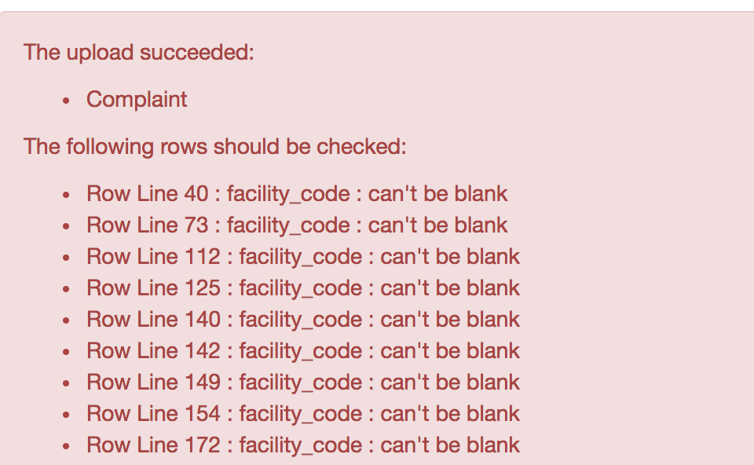

Sample output of validation errors for a Complaint CSV missing facility codes

Validation errors do not mean that the CSV is faulty and cannot be used. Some institution information is not always available when the CSV was created.

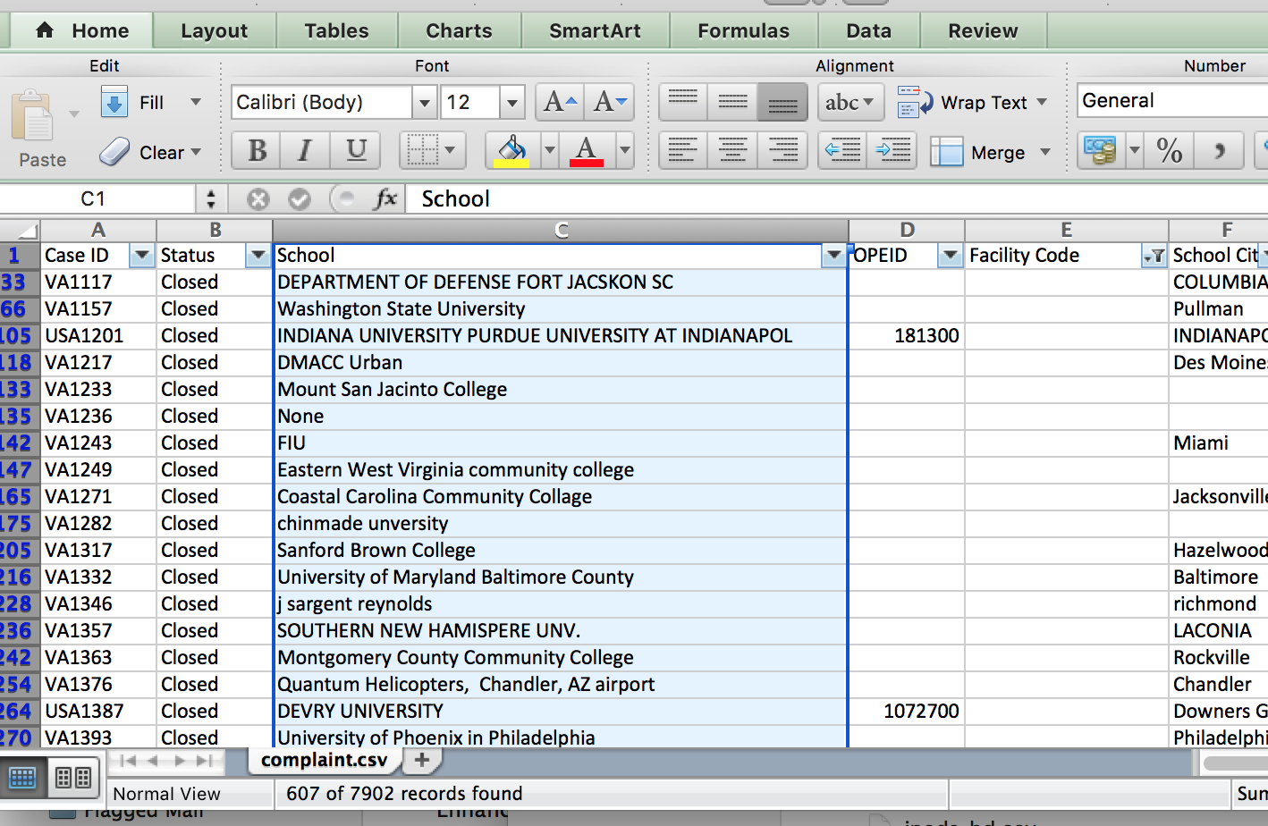

Complaint CSV having 607 institutions with missing facility codes

Additionally, “free-form” text is sometimes embedded within the data rows of some CSVs to make the information more “human-readable”, which unfortunately will confound a machine reading the CSV and trying to make sense of what it reads.

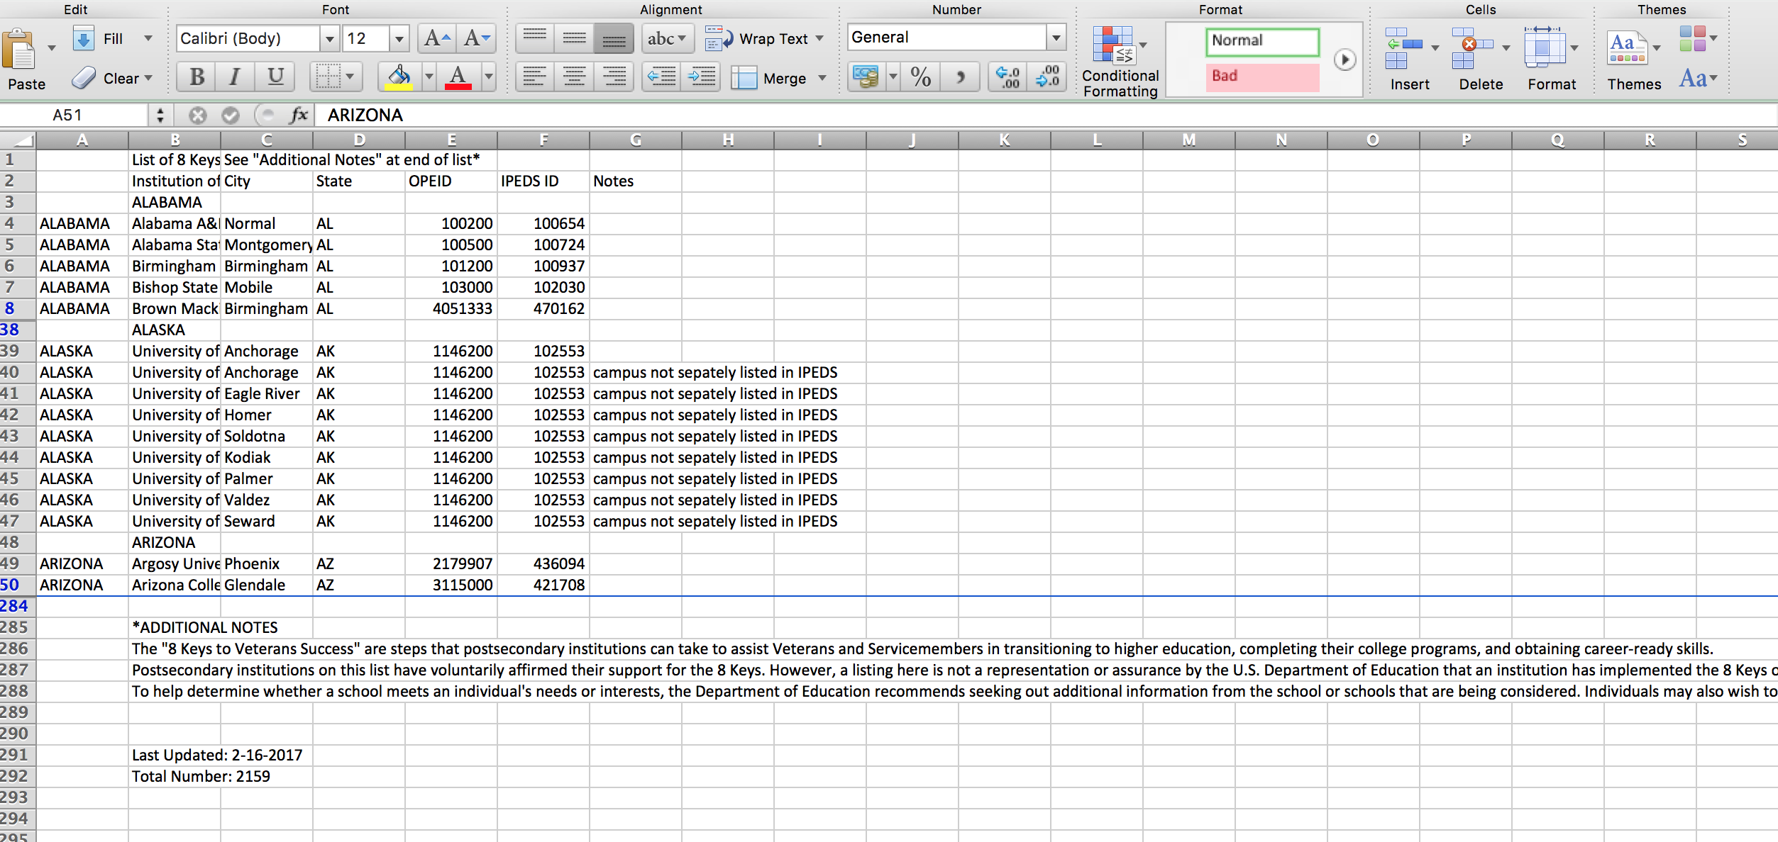

Eight-Key CSV having state names and notes embedded in the data.

These errors are a normal part of the upload process. Each row should be reviewed to ensure that this is not “corrupted data”. Unless the error message is incorrect, i.e., a value incorrectly reported as missing when in fact it is present - you need take no further action.

### Missing Columns

The information that is provided by the CSVs will change over time. If there are columns of information that are missing, a suitable warning is produced. If any information in the missing column is required by GIDS to upload the data, validation warnings will be produced as well.

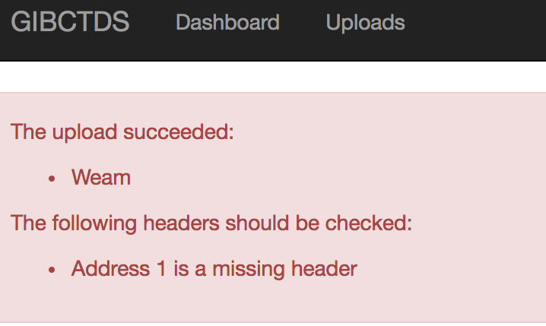

Upload from a Weams CSV that is missing an address field

Unless the missing column warning is accompanied by validation errors referring to that column by name, the issue will not affect data integrity. Please create a Github (<https://github.com/department-of-veterans-affairs/vets-website/issues>) issue notifying the Digital service team that missing columns were found. If legally permissible, please attach the CSV to the issue.

### Extra Columns

The information that is provided by the CSVs will change over time. If there are columns of information that are new and not yet accounted for by GIDS, a suitable warning is produced.

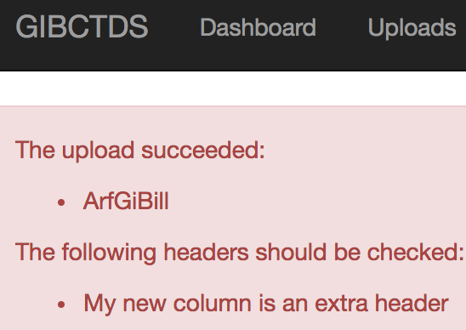

Upload from an ARF CSV having an extra column “My new column”

These types of warnings are benign. Please create a Github issue (<https://github.com/department-of-veterans-affairs/vets-website/issues>) notifying the Digital service team that new columns were found. If legally permissible, please attach the CSV to the issue.

### Renamed Columns

In the event a column is renamed, a missing header and an extra header warning will be produced. The original name will be missing and the new name will be extra.

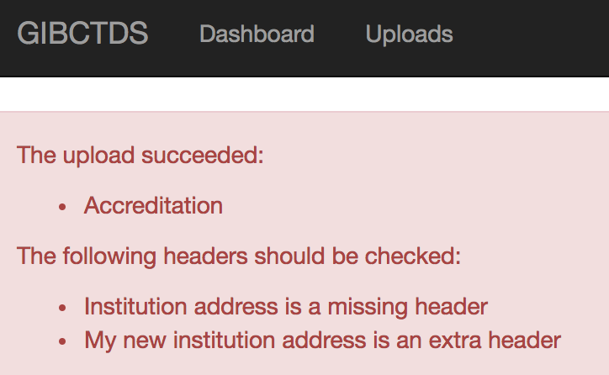

Upload from an Accreditation CSV with “Institution Address” renamed

Unless the missing/extra column warnings are accompanied by validation errors referring to that column by name, the issue will not affect data integrity. Please create a Github (<https://github.com/department-of-veterans-affairs/vets-website/issues>) issue notifying the Digital service team that missing columns were found. If legally permissible, please attach the CSV to the issue.

# Overview of Required Information

The following is a list of required columns and columns that, if present, must have a specific value for each CSV

|  |  |  |  |  |
| --- | --- | --- | --- | --- |
| **CSV Name** | **Column** | **Type** | **Required** | **Permitted Values** |
| Weam | Facility code | String | Yes |  |
| Institution | String | Yes |  |
| Bah | Number | Yes |  |
| Crosswalk | Facility code | String | Yes |  |
| Accreditation | Agency name | String | Yes |  |
| Last action | String | No | 'Resigned', 'Terminated', 'Closed By Institution', 'Probation', ’Show Cause', 'Expired', 'No Longer Recognized', 'Accredited', 'Resigned Under Show Cause', 'Denied Full Accreditation', 'Pre-Accredited' |
| Accreditation type | String | Yes | institutional', 'specialized', 'internship/residency' |
| ArfGiBill | Facility code | String | Yes |  |
| Complaint | Facility code | String | Yes |  |
| Status | String | Yes | ‘active’, ‘closed’, ‘pending’, ‘reserved’ |
| Closed reason | String | No | 'resolved', 'invalid', 'information only', 'no response', 'unresolved' |

|  |  |  |  |  |
| --- | --- | --- | --- | --- |
| **CSV Name** | **Column** | **Type** | **Required** | **Permitted Values** |
| Eight Key | Opeid | String | Yes – If Ipeds id is missing |  |
| Ipeds id | String | Yes – If opeid is missing |  |
| HCM | Ope id | String | Yes |  |
| Stop pay/Monitor method | String | Yes |  |
| Method reason desc | String | Yes |  |
| Ipeds HD | Unitid | String | Yes |  |
| Ipeds IC AY | Unitid | String | Yes |  |
| Ipeds IC PY | Unitid | String | Yes |  |
| Ipeds IC | Unitid | String | Yes |  |
| Vet2 | Number | Yes | -1, 0, 1, 2 |
| Vet3 | Number | Yes | -1, 0, 1, 2 |
| Vet4 | Number | Yes | -1, 0, 1, 2 |
| Vet5 | Number | Yes | -1, 0, 1, 2 |
| Distnced | Number | Yes | -2, -1, 1, 2 |
| Calsys | Number | Yes | -2, 1, 2, 3, 4, 5, 6, 7 |
| Mou | Ope id | String | Yes |  |

|  |  |  |  |  |
| --- | --- | --- | --- | --- |
| **CSV Name** | **Column** | **Type** | **Required** | **Permitted Values** |
| Outcome | Facility code | String | Yes |  |
| P911 Tf | Facility code | String | Yes |  |
| Number of trainees | Number | Yes |  |
| Tuition and fees cost | Number | Yes |  |
| P911 Yr | Facility code | String | Yes |  |
| Number of trainees | Number | Yes |  |
| Total cost | Number | Yes |  |
| Scorecard | NO REQUIRED COLUMNS | | | |
| Sec 702 School | Facility code | String | Yes |  |
| Sec 702 | State | String | Yes | One of the 50 states, District of Columbia, protectorate, or territory. |
| Settlement | Unitid | String | Yes |  |
| Settlement description | String | Yes |  |
| SVA | Ipeds code | String | Yes |  |
| VSOC | Facility code | String | Yes |  |